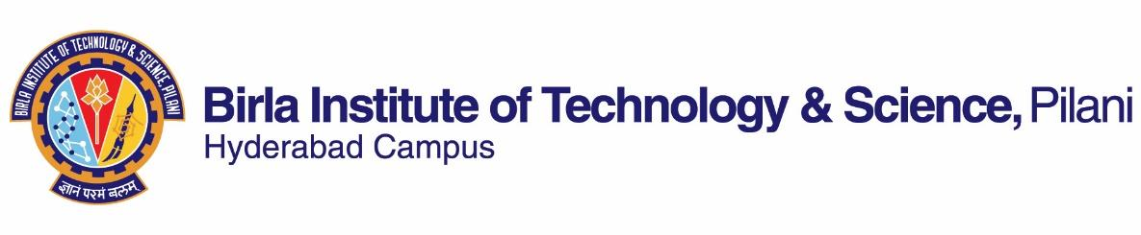

**SECOND SEMESTER 2021-2022**

# **Course Handout Part II**

Date: 31-12-2021

In addition to part-I (General Handout for all courses appended to the time table) this portion gives further specific details regarding the course.

***Course No.* : CHE G532**

## **Course Title : Alternate Energy Resources**

## **Instructor-in-Charge : Dr. Iyman Abrar**

**Description :** The scope and present day technology in utilization of solar energy, wind power, tidal power, geothermal power, M.H.D. and fuel cells.

**Scope and Objective of the Course:**

The objective of this course is to provide knowledge and a state-of-the-art learning of different sources of alternate energy resources such as solar energy, wind power, tidal power, and geothermal power, including their technologies, technical assessments, social aspects and environmental impacts pertaining to the real-world applications. Besides the theoretical knowledge, emphasis will also be provided on interactive approach to analyze different alternative energy systems. The course will be useful to the students aiming to build-up and seeking better career opportunities in the field of alternate energy resources and related technologies.

**Textbooks:**

1. Kothari, D.P et al. Renewable Energy Sources & Emerging Tech, PHI, 2nd ed., 2011.
2. John Twidell, Tony Weir, Renewable Energy Resources, 2nd Edition, Routledge, Taylor & Francis Group, 2006.

**Reference books**

1. G.N. Tiwari and R.K. Mishra, Advanced Renewable Energy Sources, RSC Publishing, 2012.
2. Robert Ehrlich, Renewable Energy: A First Course, CRC Press, Taylor & Francis Group, 2013.

**Course Plan:**

|  |  |  |  |
| --- | --- | --- | --- |
| **Lecture No.** | **Learning objectives** | **Topics to be covered** | **Chapter in the Text Book** |
| 1-3 | Introduction | Concepts of energy, alternate energy resources, relationship between energy and social implications | T1: 1  T2: 1 |
| 4-8 | Solar energy resource | Solar radiation, components, geometry and measurements | T1: 3, 4  T2: 4 |
| 9-14 | Solar thermal energy conversion | Water heater, air heaters, crop driers, refrigeration, water desalination, solar ponds, solar concentrators, and energy efficient buildings | T1: 5  T2: 5, 6 |
| 15-18 | Solar photovoltaic generation | Semiconductors, p-n junction, solar cell, cell efficiency and limitations, applications of PV systems, environmental impacts | T1: 6  T2: 7 |
| 19-24 | Wind energy | Introduction, types of turbines, harnessing of wind energy, mechanical power and electricity generation, environmental impacts | T1: 7, 8  T2: 9 |
| 25-27 | Wave and Tidal Energy | Wave-motion, energy and power, wave patterns, wave power devices, tidal energy, power from tides, environmental impacts | T1: 11  T2: ;12 |
| 28-32 | Biomass and biofuels | Biofuel classifications and production, biogas, ethanol, biodiesel, pyrolysis, environmental impacts | T1: 12  T2: 11 |
| 33-35 | Hydropower | Principles, resource assessment for small installations, types of hydroturbines, hydroelectric systems, environmental impacts | T1: 9  T2: 8 |
| 36-37 | Ocean thermal energy conversion (OTEC) | Basic principles of OTEC, closed cycle system, efficiency, applications, environmental considerations | T1: 11 |
| 38-39 | Geothermal energy resource | Geophysics, geothermal resources, harnessing energy from geothermal resources, environmental impacts | T1: 10  T2: 15 |
| 40-42 | Emerging technologies | Introduction to fuel cells, hydrogen energy and hybrid energy systems | T1: 13, 14, 15 |

Sequence of lecture may be changed depending on the situation/requirement.

**Plan for Lab experiments**

|  |  |  |
| --- | --- | --- |
| **Experiment No.** | **Lab name** | **Experiment Name** |
| 1. | Refrigeration, Air-Conditioning & Energy Laboratory* | To evaluate the efficiency of solar thermal system in thermosyphonic mode |
| 2. | To evaluate the efficiency of solar thermal system in forced mode of flow |
| 3. | To find I-V and P-V characteristics of a single PV module |
| 4. | To observe the effect of shade on I-V and P-V characteristics of a single PV module |
| 5. | To observe the cut-in speed of wind turbine, and to evaluate tip speed ratio at different wind speeds |
| 6. | To evaluate the coefficient of performance of a wind turbine |
| 7. | Analysis and characterization of wind stand-alone system |
| 8. | Petroleum Laboratory | To produce biodiesel from vegetable oil |
| 9. | To measure the calorific value of biodiesel |
| 10. | To measure the flash point and fire point of biodiesel |
| 11. | To measure the cloud point and pour point of biodiesel |

The experiments would be performed subject to availability of the instruments. The sequence of experiments may be changed depending on the situation/requirement.

**Evaluation Scheme:**

|  |  |  |  |  |
| --- | --- | --- | --- | --- |
| **Component** | **Duration** | **Weightage (%)** | **Date & Time** | **Nature of Component** |
| Mid-term test | 90 minutes | 30% | As per timetable | OB |
| Lab and assignments | 120 minutes | 35% | Continuous evaluation | OB |
| Comprehensive exam | 120 minutes | 35% | 14/05 FN | CB/OB |

**Chamber Consultation Hour:** To be announced in the class.

**Notices:** All notices concerning this course will be displayed on the CMS portal.

**Make-up Policy:** Make-up for the mid-term and comprehensive exams may be granted only with prior permission and valid justification from the instructor-in-charge. No makeup for the quiz/surprise tests will be granted.

**Academic Honesty and Integrity Policy:** Academic honesty and integrity are to be maintained by all the students throughout the semester and no type of academic dishonesty is acceptable.

**Dr. Iyman Abrar**

**Instructor-in-charge**

**Alternate Energy Resources**